# 

**AwaCare Medical Center Website Documentation**

##### 

##### *A Comprehensive Overview of Features, Structure, Code Implementation, and Development*

##### 

##### Author: Awa Afo

##### 

##### Date: October 2024

##### Website Link:<https://awaafo.github.io/AwaCare-Medical_Center/>

# 

# Table of Contents

1. **Introduction**
   * Purpose & Overview
   * Audience
2. **Project Overview**
   * Mission, Goals, Features
   * Technologies Used
3. **Website Structure**
   * Key Files & Folders
4. **Page Purposes**
   * Homepage, Services, Appointment, About, Contact
   * Form Handling
5. **Development**
   * Front-End (HTML, CSS)
   * Back-End (PHP, Security)
6. **Challenges & Solutions**
7. **Conclusion & Future Features**
8. **Appendices**
   * Code & References

# 

## 

## 1. Introduction

### Purpose & Overview

The AwaCare Medical Center website documentation provides a comprehensive guide to understanding the architecture, development, and functionality of the AwaCare website. This website was developed to create an easy-to-use platform for patients, offering them access to essential medical services such as appointment scheduling, information about services, and contact details.

The goal of this documentation is to serve as a reference for developers, maintainers, and stakeholders who want to know how the website works and how to enhance it in the future. It describes the website's features, design and coding decisions, and technological issues encountered during the creation process.

### Audience

The target audience for the documents is many groups of individuals. It's mostly intended for developers who could eventually work on the AwaCare Medical Center website. It gives them the knowledge they need to fix errors, develop improvements, and properly manage the website.They are able to decide on future enhancements and upgrades by having a thorough grasp of the technical and design elements of the website. Last but not least, it helps quality assurance teams, who have to make sure the website keeps working and being user-friendly as it changes.

## 2. Project Overview

### Mission, Goals, and Features

The AwaCare Medical Center website was created with the primary mission of improving patient access to healthcare services. The goal is to provide a user-friendly online platform where patients can easily schedule appointments, learn more about the medical services available, and contact the clinic for further assistance. The website emphasizes accessibility, ensuring that patients can navigate and interact with the site from various devices, including desktops, tablets, and smartphones.

The website includes several key features:

* **Online Appointment Booking:** A simple and efficient system that allows patients to select available time slots and services and book appointments directly online.
* **Service Information:** Detailed descriptions of all medical services provided by AwaCare, helping patients understand what care is available and make informed decisions.
* **About Us & Contact Section:** A section that introduces AwaCare’s mission, values, and team, providing background information to build trust with patients.

These features aim to streamline the patient experience, making it easier to access healthcare while improving the clinic's operational efficiency.

### Technologies Used

The AwaCare Medical Center website was developed using a combination of front-end and back-end technologies. For the front-end, **HTML** was used to create the website structure, **CSS** for styling the pages, and **PHP** for handling form submissions and back-end data processing.

* **HTML** is responsible for creating the structure of the web pages, ensuring that each section, such as the homepage, services page, and appointment form, is clearly organized and easy to navigate.
* **CSS** enhances the visual appearance of the site, providing a responsive design that adapts to different screen sizes. This ensures the website looks and functions well on mobile devices.
* **PHP** powers the form submission system, specifically for handling appointment bookings. It processes the data entered by users and sends confirmation messages, ensuring seamless communication between the clinic and its patients.

## 3. Website Structure

In order to ensure ease of navigation and maintainability, the AwaCare Medical Center website is structured logically and clearly. In order to maintain a simplified development process and enable future changes, the website's file and folder structure is essential.

### Key Files & Folders

At the root of the project directory, several key files and folders are essential to the website's functionality:

1. **index.html**: This is the homepage of the AwaCare Medical Center website. It serves as the entry point for visitors, providing a concise overview of the clinic’s services, mission, and key information. The homepage also features links to other important sections of the site, guiding users to explore further.
2. **services.html**: This page provides detailed information about the various medical services offered by AwaCare. It includes descriptions of each service.
3. **appointment.html**: This page contains a user-friendly form that allows patients to book appointments online.It has an easy-to-use interface that lets users choose their desired dates and services, making scheduling convenient for both patients and clinic employees.
4. **about.html**: This page outlines the clinic's mission, values, and team. It highlights AwaCare’s commitment to providing high-quality healthcare services, reinforcing trust and transparency with potential patients.
5. **contact.html**: This section offers multiple ways for patients to connect with the clinic, including phone numbers, email addresses, and a contact form. It ensures that patients can easily reach out for inquiries or support.
6. **processorder.php**: This script processes form submissions from the website, notably those from the appointment scheduling form. It processes the data collected, ensuring that appointment requests are accurately recorded and sent to the appropriate staff.
7. **styles.css**: This file contains all the CSS styling rules for the website, ensuring a consistent visual experience across all pages. It centralizes design elements such as colors, fonts, and layout, contributing to the overall aesthetic and usability of the site.
8. **images**: This directory stores all visual assets used throughout the website, including logos, icons, and other images. Having a dedicated folder for images helps maintain organization within the project.
9. **documentation.md**: This file serves as a comprehensive resource detailing the website’s structure, development processes, and future enhancement opportunities. It provides insights into the website's architecture and serves as a reference for developers and maintainers.

## 4. Page Purposes

Each page of the AwaCare Medical Center website has a specific purpose, contributing to the overall user experience and functionality of the site:

1. **Homepage**: The homepage welcomes visitors with an overview of AwaCare's mission and key services. It acts as the central hub, directing users to other sections of the site and providing easy navigation options.
2. **Services Page**: This page delves into the various medical services offered by AwaCare, providing detailed descriptions, procedures, and qualifications of the medical staff. It helps patients make informed decisions about their healthcare needs by clearly outlining the available services.
3. **Appointment Page**: The appointment page simplifies the booking process for patients by providing a user-friendly form. Users can select their preferred date and time, choose a specific service, and submit their personal information easily, enhancing clinic efficiency.
4. **About Page**: The about page provides background information on AwaCare's mission, values, and team. It communicates the clinic’s commitment to patient-centered care and ethical practices, helping to build trust with potential patients.
5. **Contact Page**: The contact page offers multiple ways for patients to connect with AwaCare, ensuring they can easily reach the clinic for inquiries or support. This page may include phone numbers, email addresses, and a contact form for convenience.

### **Form Handling**

Form handling is a critical aspect of the AwaCare Medical Center website, particularly for the appointment booking process. The **processorder.php** script plays a pivotal role in this area.

1. **Data Submission**: When a user submits the appointment booking form, the information is sent to the **processorder.php** script. This script handles the incoming data securely, ensuring that it is processed efficiently and stored appropriately.
2. **Data Validation**: To maintain the integrity of the information received, both client-side and server-side validation measures are implemented. Client-side validation prompts users to fill out required fields before submission, while server-side validation in the PHP script checks the data for completeness and correctness after it has been submitted.
3. **Security Measures**: The script uses functions like htmlspecialchars() to prevent security vulnerabilities, protecting against potential threats such as SQL injection and cross-site scripting (XSS). This ensures that patient data is handled safely and securely.
4. **User Feedback**: After the form is processed, the script sends confirmation messages to users, providing immediate feedback on their appointment booking. This enhances the user experience by keeping patients informed and engaged with the booking process.

## 5.Development

### **Front-End Development (HTML, CSS)** The AwaCare Medical Center website uses semantic HTML and CSS for a user-friendly interface. The styles.css file ensures consistent styling, and media queries enhance responsiveness across devices.

**Back-End Development (PHP, Security)**PHP handles form submissions securely through the processorder.php script, utilizing functions like htmlspecialchars() to protect against vulnerabilities. Confirmation messages are sent after successful appointment requests to enhance user trust.

## 6. Challenges & Solutions

* **User Engagement**
  + **Challenge**: Low user return rate.
  + **Solution**: Add interactive elements like blogs and newsletters.
* **Technical Issues**
  + **Challenge**: Bugs affecting functionality.
  + **Solution**: Conduct regular testing and implement monitoring tools.
* **Content Management**
* **Challenge**: Keeping information updated.
* **Solution**: Use a CMS for easy updates and schedule regular content reviews.

## 7. Conclusion & Future Features

The AwaCare Medical Center website successfully integrates user-friendly design with robust security measures, creating an efficient platform for patient engagement and appointment scheduling. By prioritizing accessibility and clarity, the website enhances the overall patient experience and fosters trust in the clinic's services. In the future, the website hopes to add further features, such as a secure patient portal for quick access to medical records, an online payment gateway for seamless transactions, and a health blog for instructional materials. These improvements will foster a culture of health and wellbeing in the community in addition to enhancing patient engagement. The AwaCare Medical Center website is positioned to be an essential resource for patients and healthcare providers in the future by continuously changing and adapting to patient demands.

## 8. Appendices

#### **Code & References**

This section provides supplementary materials, including relevant code snippets and references for the AwaCare Medical Center website. These resources will help developers understand the code structure and facilitate future enhancements.

**Key Code Snippets:**

**HTML Structure**The homepage (index.html) uses semantic HTML to ensure accessibility and SEO optimization. Below is a snippet of the homepage structure:  
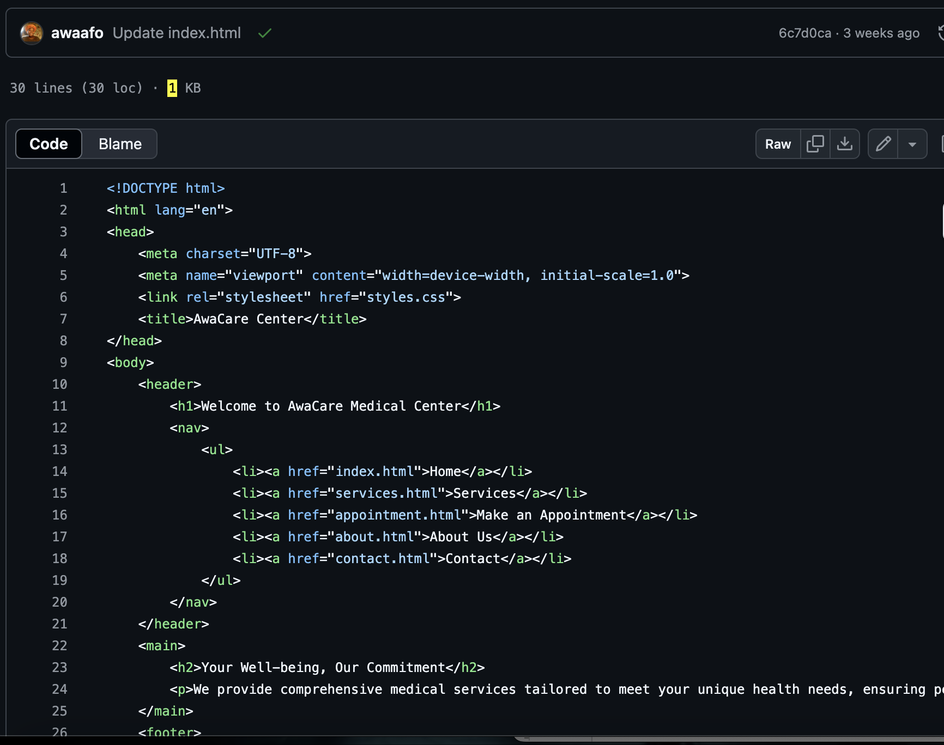

**CSS Styling**The styles.css file centralizes styling for consistent design. Here’s a basic example of styling applied:  
css  
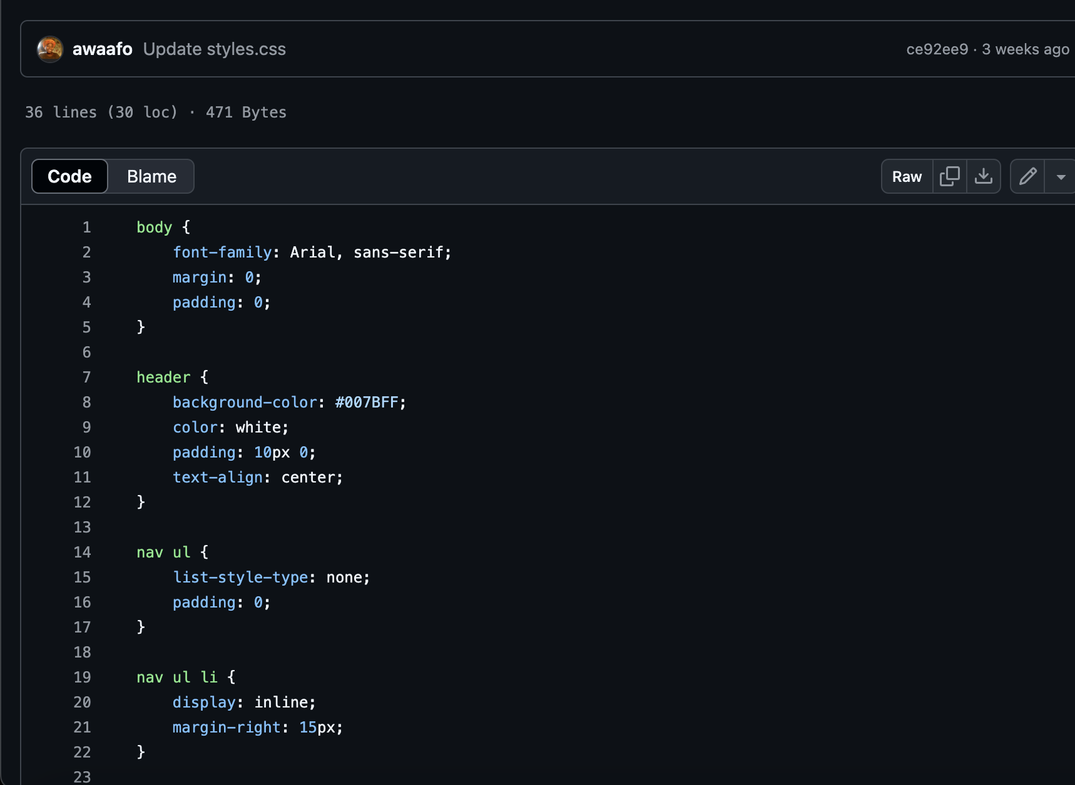

**PHP Form Processing**The processorder.php script handles form submissions securely. Below is a snippet showcasing how data is processed:  
php

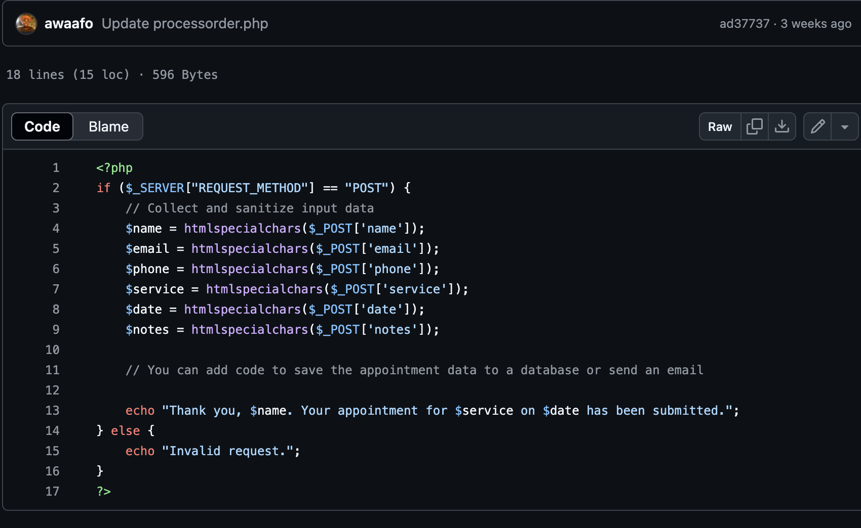

# 

# Glossary

**AwaCare Medical Center**: A fictional healthcare facility represented by the website, providing medical services and appointment scheduling for patients.

**Back-End Development**: The server-side development that involves creating the logic and functionality of the website, typically using programming languages such as PHP to handle requests, process data, and manage the database.

**CSS (Cascading Style Sheets)**: A stylesheet language used to describe the presentation of a document written in HTML or XML, controlling layout, colors, fonts, and overall visual design of the website.

**Front-End Development**: The client-side development that focuses on the visual aspects of the website, including HTML and CSS, ensuring an engaging and user-friendly interface for visitors.

**HTML (Hypertext Markup Language)**: The standard markup language for creating web pages, structuring content and layout.

**Media Queries**: A CSS technique used to apply different styles based on the viewport size or device characteristics, enabling responsive design for various devices (desktops, tablets, smartphones).

**PHP (Hypertext Preprocessor)**: A server-side scripting language designed for web development, used to create dynamic web pages and handle data processing.

**Processorder.php**: A PHP script responsible for handling form submissions on the website, including processing appointment requests and ensuring secure data handling.

**Responsive Design**: An approach to web design that ensures a website looks and functions well on various devices and screen sizes by adapting layouts and content accordingly.

**Semantic HTML**: The use of HTML markup that conveys meaning and structure, utilizing elements like <article>, <aside>, and <nav> to enhance accessibility and SEO.

**User Experience (UX)**: The overall experience a user has while interacting with the website, encompassing aspects such as usability, accessibility, and satisfaction.

**Validation**: The process of ensuring that user input meets specified criteria before being processed or stored, used to prevent errors and security vulnerabilities.